Fall (12 credits):

Year One

SOW 6125 Human Behavior and Social Environment II (3) PHC 6052 Biostatistics I (3)
PHC 6102 Introduction to Public Health Policy &Management (3) PHC 6410 Health Behavior and Public Health (3)

Spring (12 credits):
SOW 6435 Evaluating Empirically Bases Social Work Practice (3) SOW XXXX Clinical Social Work Elective (3)
PHC 6000 Introduction to Public Health Epidemiology (3) PHC 6602 Theoretical Foundations of Health Promotion (3)

Summer (9 credits):
SOW 6236 Social Welfare Policy & Services II (3) PHC XXXX Public Health Elective (3)
PHC 6315 Introduction to Environmental Health (3)

Year Two
Fall 2 (12 credits):
SOW 6425 Clinical Assessment and Intervention Planning (3) SOW 6533 Field Practicum II (3) [PHC 6945 Practicum in PH is
embedded into SOW 6533]
PHC 6146 Health Promotion Program Planning and Intervention Design (3) PHC 6706 Research Methods in Public Health (3)

Spring 2 (12 credits):
SOW 6351 Clinical Intervention in Couple and Family Social Work Practice (3) SOW 6534 Field Practicum III (6) [PHC 6945 Practicum in PH may be embedded into SOW 6534
if student continues hours into summer semester]
PHC 6750 Program Development & Evaluation for Health Promotion (3)

Summer 2 (9 credits):
PHC 6930c Integrative Seminar in Public Health (3)
PHC XXXX Public Health Elective (3)
SOW XXXX Clinical Social Work Elective (3)

MSW/MPH
Degree Pathway

Health Promotion and Disease Prevention / Social Work
Master (MSW) Advanced Standing

Fall Admit 66 credits

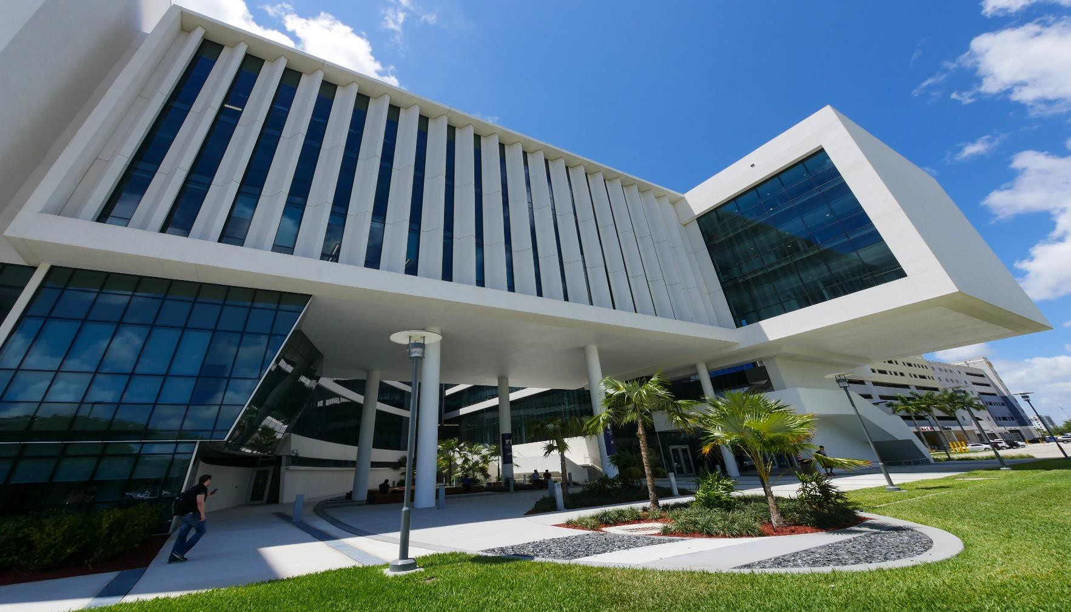

11200 SW 8th Street, Miami, FL 33174 Academic Health Center Five ST E MP E L . F I U . E D U

